Instructions for Importing Unformatted Bibliographies into EndNote

1. Open the unformatted bibliography in MS Word. Ensure that each bibliographic reference *(which we may also refer to as a* ***record****)*, begins on a new line. This can be done by clicking on the “show all nonprinting characters” button in MS Word, which is indicated in the screenshot below:



Clicking on that button will cause the blue paragraph marks *(aka. pilcrows)* to show up. For this macro to function correctly, **there should be a pilcrow at the end of each record**. Here is a screenshot of what this should look like:

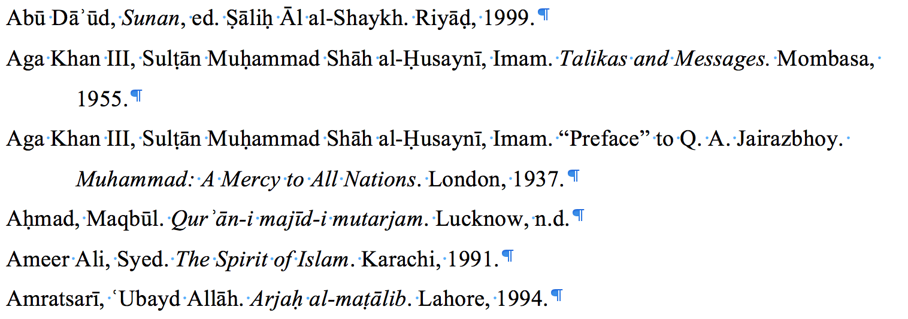

Also ensure that the records are not numbered and don’t have leading whitespace in the records. This can be done as follows: *(this can be skipped if the records are not numbered and there is no leading whitespace)*

1. Import and run the latest version of the ‘**TagItalic**’ macro which is included in the ‘**TagUnformattedBib.bas**’ file. *(For instructions on how to import and run a macro in Microsoft Word, refer to* [*this five-minute video*](https://www.youtube.com/watch?v=Z0Oo7G9BLPU)*)*

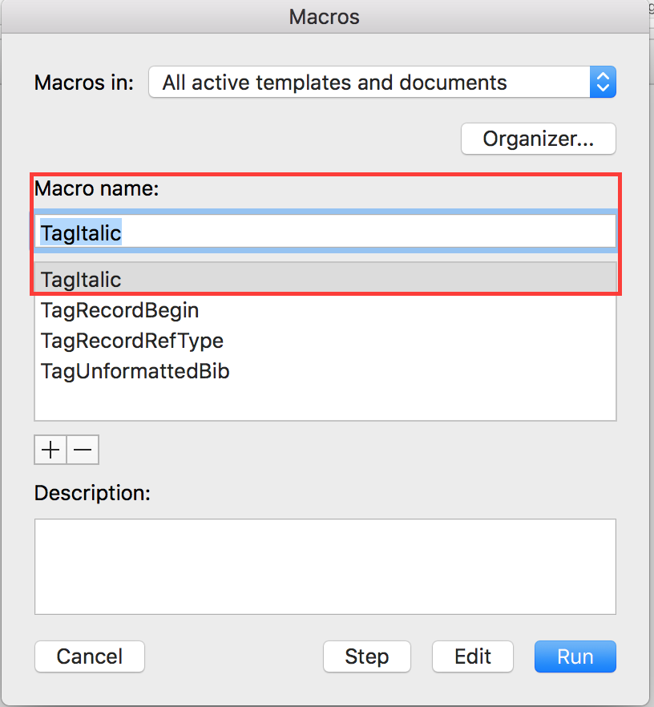

This macro should add “<i>” (opening) and “</i>” (closing) tags around *italic text*. For example, “*the quick brown fox”* would change to “<i>the quick brown fox</i>”. This needs to be done because the tools being used in steps “B” and “C” below do not preserve the formatting of text and therefore, italic text can’t be identified once the tools have been used.

1. After running the macro in step “A”, **If the records are numbered**, copy all the text in the document and use [this website](http://alphabetizer.flap.tv/remove-numbers-from-beginning-of-each-line.php) to remove numbering. If the records are not numbered, this step can be skipped.
2. Copy the resulting text from step “B” and use [this website](https://www.miniwebtool.com/remove-leading-trailing-spaces/) to remove whitespace from the text. If step “B” was skipped, use the text from the document and remove whitespace from it.
3. Import and run the latest version of the ‘**TagUnformattedBib**’ macro which is included in the ‘**TagUnformattedBib.bas**’ file. This macro will add a line before each record in the document, which will indicate the reference type of that record. *(This may be referred to as “tagging”)*. It will also add a “x--” mark at the start of every record, which helps EndNote identify the start of a new record when this file is imported into EndNote. Therefore, once this macro is run, EndNote should be able to identify the type and the starting point of each record that is successfully recognized by the software.  
     
   Based on the reference type of the record, each record will be tagged with one (or more) of the following tags: *(The next step explains why multiple tags might be added to a record)*
   1. ‘**DT:BK**’ if the reference represents a book *(This stands for* ***D****ocument* ***T****ype:* ***B****oo****K****)*
   2. ‘**DT:BS**’ if the reference represents a book section *(****BS*** *stands for* ***B****ook* ***S****ection)*
   3. ‘**DT:JA**’ if the reference represents a journal article *(****JA*** *stands for* ***J****ournal* ***A****rticle)*
   4. ‘**DT:MS**’ if the reference represents a manuscript *(****MS*** *stands for* ***M****anu****S****cript)*
   5. ‘**DT:TD**’ if the reference represents a thesis or a dissertation *(****T*** *stands for* ***T****hesis and* ***D*** *stands for* ***D****issertation)*

Below is a screenshot of a tagged file:

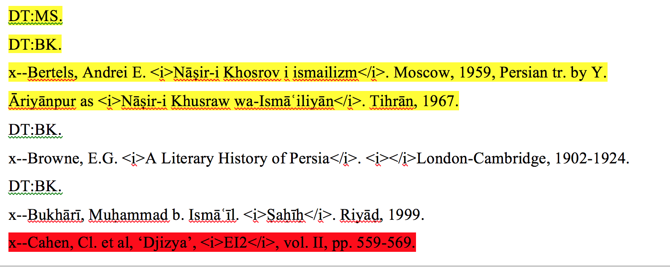

1. After running the macro, all references which the software failed to recognize the type of will be highlighted in red. Consequently, **these records need to be identified manually by the user**. This can be done by adding “DT:BK.”, “DT:JA.” or “DT:MS.” on a separate line above the record.  
     
   Moreover, If the software thinks that a record can belong to multiple reference types *(e.g. “book” and “manuscript” for the yellow record in the screenshot shown above)* and it is confused about which reference type to use, it will highlight that record in yellow and list the multiple types, which it is confused between, above the record. This can be referred to as a **conflict**. **Resolve all of these conflicts by deleting the tag which the reference does not correspond to**. For example, in the screenshot shown above, the first reference in yellow is actually a book, but the software thought it could’ve been a manuscript and thus, it added both “DT:MS” and “DT:BK” above the record. Below is a screenshot showing how to fix this file by removing the line which contained “DT:MS”, since the user understands that reference is not a manuscript. *(The yellow highlighting doesn’t need to be removed because it doesn’t affect the outcome of the next steps. However, zero or multiple tags for a record could cause the filter to malfunction)*

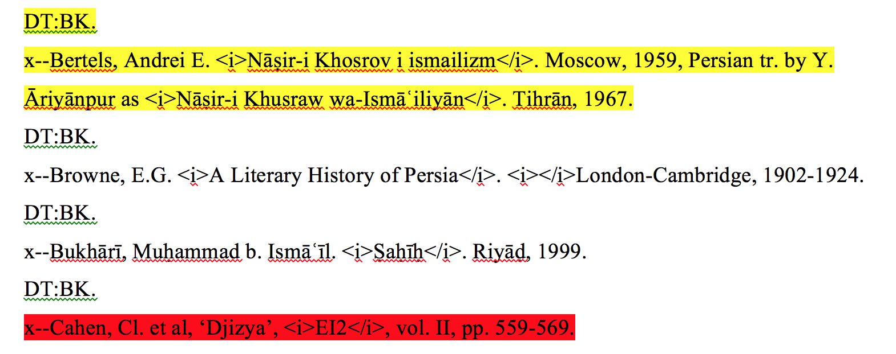

1. Once all the lines highlighted in red have been manually tagged and all the conflicts highlighted in yellow have been resolved, press “Ctrl + A” on the keyboard to select all of the text in the file, copy the selected text and paste it into a new text (.txt) file. *(*[*This link*](https://www.computerhope.com/issues/ch001359.htm) *has instructions on how to create a new text file)*. Save this text file in a preferred location; this text file will be imported into EndNote in the upcoming steps. *(Do not use “Save As” to export the document as a text file, use this copy-paste method instead).*
2. Place the ‘**ImportUnformattedBib.enf**’ file under the “Filters” folder which is located in the “EndNote” folder in “My Documents” *(or just “Documents” on a Mac)*. This is how EndNote will detect this import filter.
3. Open EndNote and import the newly created text file into EndNote. Ensure that the ‘**ImportUnformattedBib**’ import filter is selected in the import options. This can be done by:
   1. Clicking “File -> Import” in EndNote,
   2. Then navigating to the location where the text file was saved in Step 4 above and selecting that text file
   3. Then selecting the ‘**ImportUnformattedBib**’ filter from the “Options” tab. (see screenshot below)

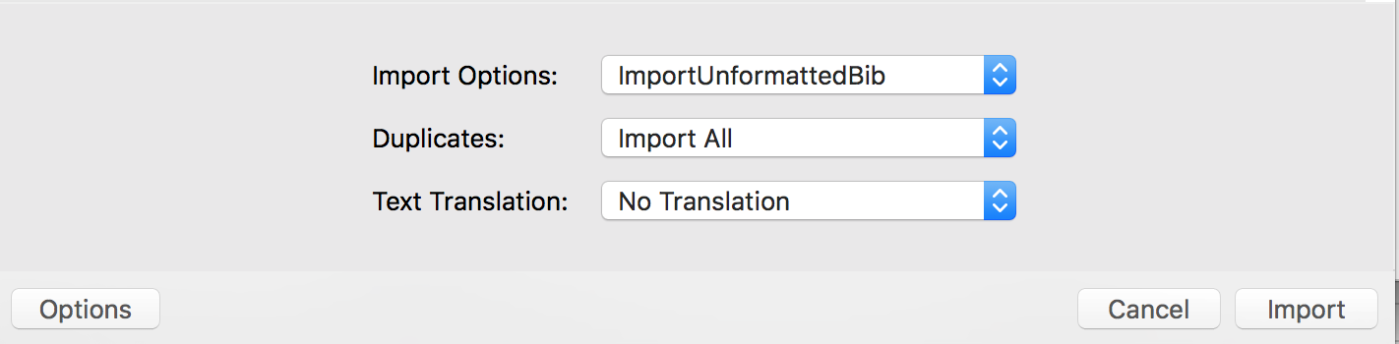

1. The records which the import filter fails to recognize will be imported as references with all the information added to the “Notes” field instead of the respective fields where they belong. (see screenshot below)

